**Root Commands**

**Command1**: Which rider won World Cup Cyclocross - Elite Women in 2024?

**Command2**: List the teams that ride Colnago bikes.

**Command3:** List the name of every race won by a rider who has more than 50 professional wins.

**Command 4:** List the names of all the riders on the same team as the winner of the 2010 Paris-Roubaix race.

**Command 5:** Insert the rider Mark Renshaw into the riders table.

**Before**

**After:** (Alert was giving for successful update, I’m sorry I forgot to screenshot that specific one. You can see Mark was placed in and the alerts in later screenshots. Simply did not want to mess up the operationslog part)

**Command 6:** List the names of those riders who have won Paris-Roubaix at least two times.

**Command 7:** Delete all the riders from Belgium from the riders table.

Before:

**Confirmation:**

**After:** (Roger deVlaeminick gone for example)

**Command 8:** Update rider Mark Renshaw to show number of wins = 30 in the riders table.

**Before:**

**During:**

**After:**

**Command 9:** This command is malformed and will not execute

**Command 10:** update rider Ceylin del Carmen Alvarado to show number of wins = 89 in the riders table. Then query the riders table to list all riders with exactyl 89 wins.

**Confirmation:**

**After:**

**CLIENT1 COMMANDS**

**Command 1:** Which rider won the World Championship - Elite Women in 2021?

**Command 2:** Delete all the riders from Norway from the riders table.

Before:

**During: (Error)**

**After:**

**Command 3:** Update rider Marianne Vos to show number of wins = 245 in the riders table.

**During: (Error)**

**After:**

**Command 4:** Which rider won the 2024 Tour de France?

**Command 5:** How many riders are there?

**Command 6:** updating command not valid for the client user

**Command 7:** How many races list Ceylin del Carmen Alvarado as the winner?

**Client 2 Commands**

**Command 1:**

**Command 2**: Delete all the riders from Italy from the riders table.

**Before:**

**During: (error)**

**After:**

**Command 3:** Update rider Annemeik van Vleuten to show number of wins = 210 in the riders table.

**Before:**

**During:**

**After:**

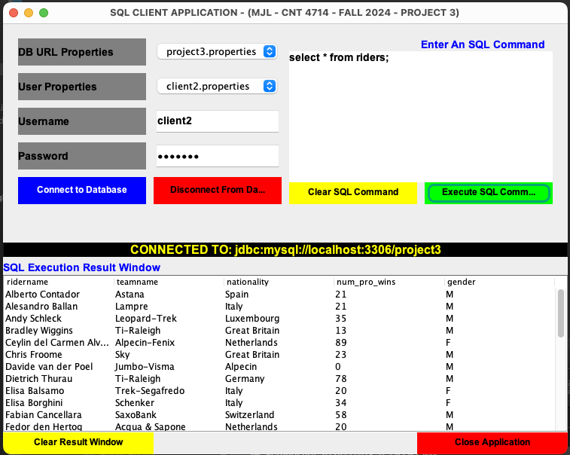

**Command 4:** Which rider won the 2021 Tour de France?

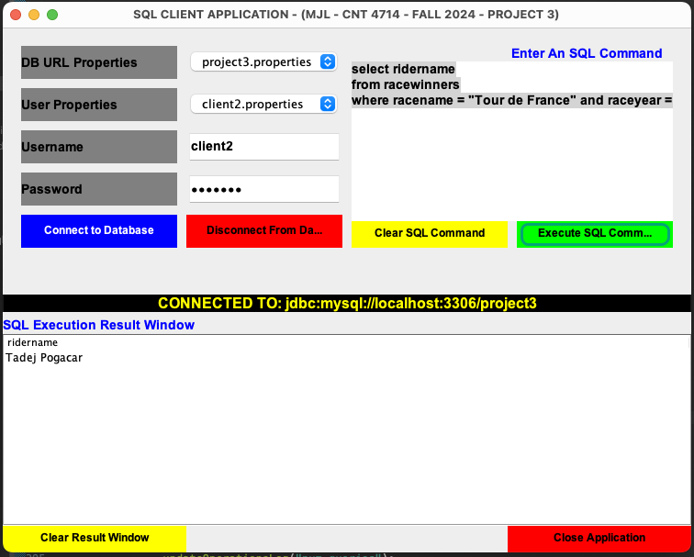

**Command 5:** How many riders are there?

**Command 6:** updating command is valid for client2 user

**Command 7**: How many races list Ceylin del Carmen Alvarado as the winner?

OPERATIONSLOG COMMAND

**Command 1:** Selecting num_queries from root account

**Command 2:** Operationslog table

**Workbench Screenshot**

**More Screenshots**

**CREDENTIALS MISMATCH: (User name: client1 password: client1)**

**(Username: root, password: root [not actual password])**

**DISCONNECTION:**

